OOPS LAB

Experiment -1

NAME- ANMOL YADAV SAP ID- 500083814 ROLLNO- R214220178

**Java Versions-**

There are a lot of versions of java are available online.

Currently 4 version of JAVA JDK are available

* 1. Java SE 16
  2. Java SE 11(LTS)
  3. JAVA SE 8
  4. JAVA SE 7

From the above versions, Java SE 16.0.1 is the latest release for the Java SE Platform in which we are going to work.

Today we also learn that the OS will throw error if there is difference in the version of java basically if the file is created in new version of java, the OS with older version of Java with throw the error, the file will not execute but vice-versa is not be a case as all new versions have all properties of the older one like hierarchy.

During the lab we install “JAVA SE 16.0.1” version

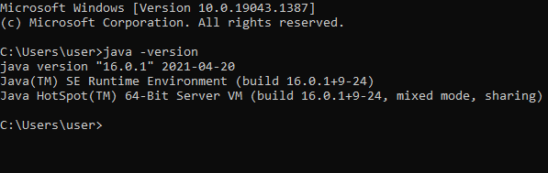

1. Path Setting –

The PATH variable is just that, a variable. More specially, it is an environment variable that is used across both Windows and Unix operating systems.

PATH is an environment variable on Unix-like operating systems, DOS, OS/2, and Microsoft Windows, specifying a set of directories where executable programs are located. In general, each executing process or user session has its own PATH setting.

Example- we can directly open calculator in our system (OS-Windows) by giving “calc” command in command prompt. This is because the path of calculator is saved as variable environment in our system so that on giving direct command calculator was opened.

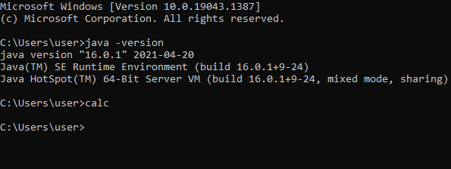

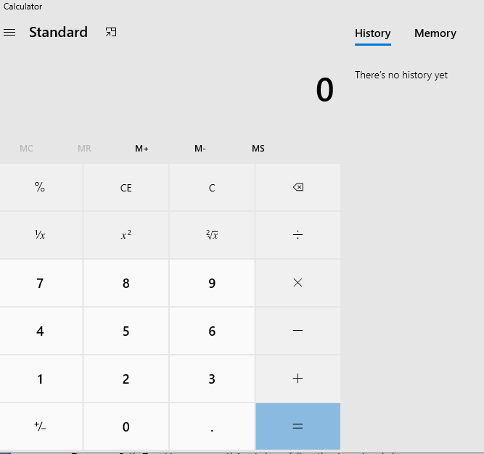

Similarly, if we have to add path of java into our system variable environment so that the system directly accesses the java in one command.

Setting Path: There are two ways two set path in java(in windows):Temporary path and permanent path.

Temporary Path: To set temporary path in windows, follow the steps given below:

1. Open the command prompt
2. Copy the path of the JDK/bin directory
3. Write in command prompt: set path=copied path

Permanent Path set:

We add JAVA path in environment variable in system settings.

these screenshot shows the how to set path

1. Open Edit Environment variable from the settings. And add the path of Bin folder.

**C:>Program Files>Java>jdk-16.0.1>bin**

1. Environment Variable> System Variable>new.

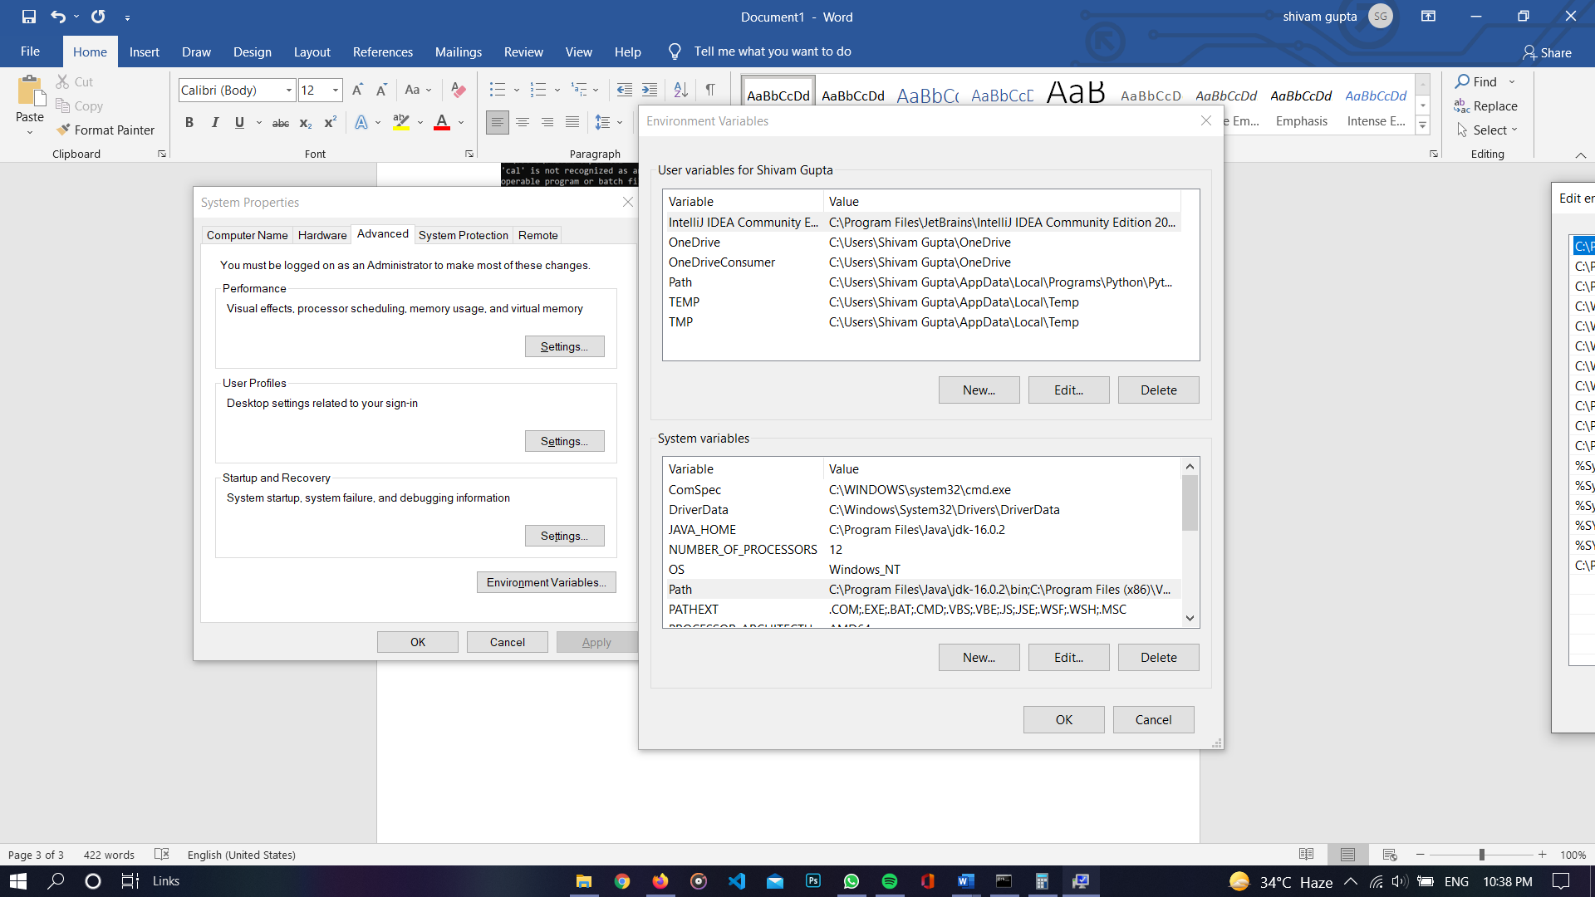

1. New>Add path-C:>Program Files>Java>jdk-16.0.1>bin**.**

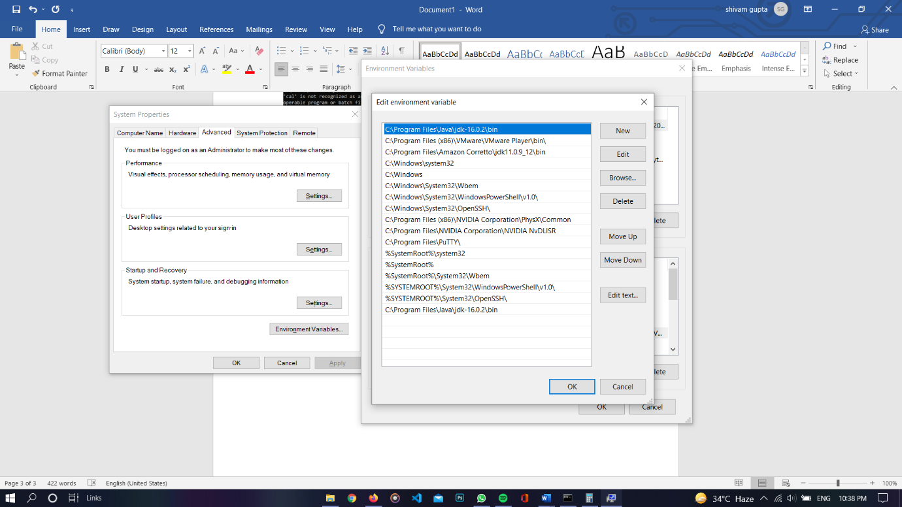

1. **Path is in JAVA_home there we now see the path**

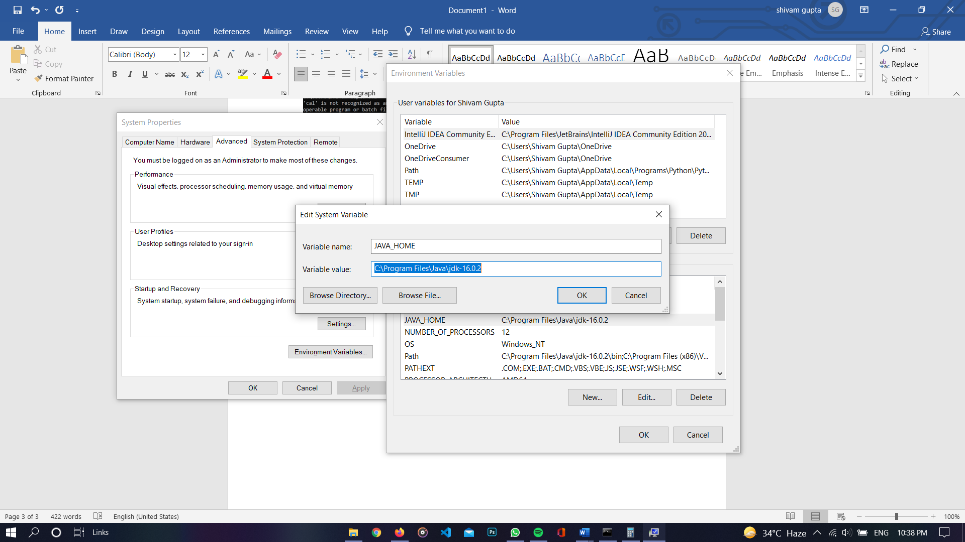

**Code Editor**

A text editor that is specialized for writing software. A source code editor may be a stand-alone program or part of an integrated development environment (IDE). They make writing and reading the source code easier by differentiating the elements and routines so programmers can more easily look at their code.

**NOTEPAD**-**Notepad**is a free and open-source code editor for Windows. It is easy to use for beginners, as in we have to write the whole program by our own. It doesn’t give suggestions, syntax error, it don’t have templates, boiler-plates, extension which help us.

Other Source-code editors have features specifically designed to simplify and speed up typing of source code, such as syntax highlighting, indentation, autocomplete and brace matching functionality. These editors also provide a convenient way to run a compiler, interpreter, debugger, or other program relevant for the software-development process.

Other code Editors-VS Code, IntelliJ IDEA, Eclipse and many more

**IntelliJ IDEA**-IntelliJ IDEA is a multi-purpose IDE which focuses on Java development. It is one of the best Java compilers that offers advanced support for the web, mobile, and also hybrid application development

**Eclipse:-** Eclipse is an integrated development environment (IDE) for developing applications using the Java programming language and other programming languages such as C/C++, Python, PERL, Ruby etc.

**Sample Hello world program-**

**code**

**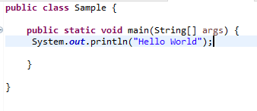  
Output**

